Careers and Leadership Workshop
Description
What follows is a series of lesson plans and materials intended to introduce high schoolers to ideas about careers and leadership. It should be considered a rough draft; the materials were developed from scratch and only taught once by Andrew BoddySpargo of Journey House, Inc. in 2016. Feel free to use or adapt them as you see fit, and I suggest that you work on incorporating more dynamic and engaging activities into the lessons. They’re designed to last for about an hour, but with more activities and student work time, they could easily fill 90 minutes.
Each lesson plan follows the same structure and is followed by a worksheet to help guide student responses and note-taking. Teacher materials are included where referenced, and the last pages contain a post-test that should also be used as a pre-test to assess the information that was retained. Any feedback or improvements can be shared with Andrew at andrew.boddyspargo@gmail.com. Happy teaching!

Table of Contents
Session 1: How to Make Money
Session 1 Worksheet - How to Make Money
Session 2: How to Keep Money - Budget & Savings
Session 2 Worksheet - How to Keep Money: Budget & Savings
Session 2 Teacher Materials
Session 3: How to Keep Money - Credit
Session 3 Worksheet - How to Keep Money: Credit
Session 4: How to Get a Job - The Steps
Session 4 Worksheet - How to Get a Job: The Steps
Session 5: How to Keep a Job and Get Promoted
Session 5 Worksheet - How to Keep a Job and Get Promoted
Session 6: How to Start and Run a Business
Session 6 Worksheet - How to Start and Run a Business
Session 6 Teacher Materials
Careers and Leadership Pre- and Post-Test
Pre- and Post-Test Answer Key

Session 1: How to Make Money
Learning Objectives:  - Measurable student learning (not activities).  - Student-friendly language. | - Students will get to know the instructor and generate a list of learning goals  - Students will understand what they will learn in the workshop  - Students will understand how to make money
Key Points:  - Central ideas from the lesson.  - What might students have difficulty with? | - Want to gauge student interests to focus future lessons and activities  - How to categorize different money-making strategies
Exit Assessment:  - How will you know if the learning objectives above were achieved? | - Exit ticket will ask the most interesting thing they learned about Mr. BoddySpargo today, what are three different strategies for making money, what all strategies for making money have in common, and what are three things they’ll learn in the workshop.
Heart of the Lesson (Agenda):  - Outline or bullet-point format.  - Lists time-stamped, objectives-aligned learning activities that will guide learning  - Key-point-aligned CFUs (Checks for Understanding) written in bold  - Begins with an Activator and ends with an Exit Assessment (Summarizer) | - Do Now activity: Answer these questions on a sheet of paper [5 min]  - How much money do you need to make to be happy?  - What is the best job you’ve ever heard of?  - What do you love to do the most?  - What is currently your best skill?  - What is one skill you want to learn before age 20?  - Teacher introduction [5 min]  - Where from, jobs, and education  - Share answers to questions  - Students share their answers with the class [10 min]  - Stand up, say name, share answers  - Overview of the class [5 min]  - Purpose: give students ideas and tools to do what they want with their lives  - Topics: list of topics  - Expectations: Respect for time and energy, respect for one another, collaborative atmosphere  - Brainstorm strategies to make money [10 min]  - Ask students to raise their hands and share one-by-one  - Sort into four (initially untitled) categories: service or production (cross-category strategies: work for someone else, manage people, start/own a business, invent something)  - What do all these strategies have in common? They create value for others.  - Think of the entire economy as people creating value for each other and ask yourself: how can I create value for others and get them to pay me for a part of the value I create for them? CFU: do you agree with this? Can you think of an example of this idea?  - What are things that I can do to make me more able to create value for others? Come up with a list of ideas. Point out that a good place to start is to learn what you can do, which is the goal of this workshop.  - Student writing activity: Write three complete sentences that describe ways that you could realistically create value for others in the future. [5 min]  - Student revising activity [15 min] CFU: explain to me what you’ll do first in this activity, etc.  - You will have a partner and you will read and give suggestions about your partner’s sentences  - 1) read your partner’s first sentence  - 2) write “yes” next to it if you think it’s a realistic way to create value for others  - 3) add a suggestion for how to make it better or more realistic, if you can  - 4) repeat for other sentences  - 5) be prepared to share your favorite sentence that your partner wrote  - Brainstorm topics for this class activity [5 min]  - Revisit the topics for this class  - Ask which ones sound useless  - Ask what they want to add to the list  - Ticket Out [5 min]
Necessary Materials: | - Worksheets with space for name, activator questions, space for writing sentences and space for partner feedback, space for ticket out, spare pens
Reflection:
- What were the most successful parts of the lesson?
- What will you do differently next time?

Session 1 Worksheet - How to Make Money
Name: __________________________
Do Now:
- How much money do you need to make to be happy?

- What is the best job you’ve ever heard of?

- What do you love to do the most?

- What is currently your best skill?

- What is one skill you want to learn before age 20?

Write three complete sentences that describe ways that you could realistically create value for others in the future:
Your sentences below | Partner responses
1)

2)

3)

Respond to these questions before you hand in this worksheet:
- What’s the most interesting thing you learned about Mr. BoddySpargo today?

- What are three different ideas you heard today for making money?

- What do all strategies for making money have in common?

- What are three things you’ll learn in this workshop?

Session 2: How to Keep Money - Budget & Savings
Learning Objectives:  - Measurable student learning (not activities).  - Student-friendly language. | - Students will estimate take-home pay  - Students will create a basic budget  - Students will calculate interest earned in a savings account  - Students will explain how compounding interest works
Key Points:  - Central ideas from the lesson.  - What might students have difficulty with? | - A budget helps make sure you are using your money well, otherwise you’re just guessing  - Compounding interest adds to the total amount and increases each time
Exit Assessment:  - How will you know if the learning objectives above were achieved? | - Exit ticket will ask students to write a sentence explaining how compounding interest works.
Heart of the Lesson (Agenda):  - Outline or bullet-point format.  - Lists time-stamped, objectives-aligned learning activities that will guide learning  - Key-point-aligned CFUs (Checks for Understanding) written in bold  - Begins with an Activator and ends with an Exit Assessment (Summarizer) | - Do Now activity: Answer the questions on the handout [5 min]  - We Do: Budgeting [15 min]  - Brainstorm what students would spend their money on each month if they made $36,000 per year ($3,000 per month) before taxes  - Combine ideas into a monthly budget table  - Explain different taxes and use 25% as estimator for withholdings to calculate annual and then monthly take-home salary  - Determine if the paycheck can cover expenses  - If not, reduce some categories of expense  - You Do: [15 min]  - Students get salary numbers and they must complete their own budget  - Share out: were they able to spend less than they make? Any surprises? Highest savings? [5 min]  - The power of compounding interest example: $200/month for 30 years, 6% compounded monthly = $72,000 contributed and total of $200,000 ($128,000 earned in interest!)  - Define: [5 min]  - APR - Annual Percentage Rate  - Compound - Calculate interest and add it to amount  - Interest - %number/100*amount  - I Do: Savings Account example [10 min]  - APR of 3% compounding monthly- what is first month’s interest? Second?  - We do: together we figure out:  - APR of 12% compounding monthly - first month, second?  - Ticket Out [10 min]
Necessary Materials: | - Teacher Materials, Student Worksheets
Reflection:
- What were the most successful parts of the lesson?
- What will you do differently next time?

Session 2 Worksheet - How to Keep Money: Budget & Savings
Name: __________________________
Do Now:
What do all strategies for making money have in common?

How much do you think it costs to pay rent or a house mortgage each month?

What percent of everyone’s paycheck do you think is taken in taxes?

What is your annual salary? ___________
What is your annual take-home salary? __________
What is your monthly take-home pay? ___________
Category of Spending | $ per month
Housing
Food
Utilities and Insurance
Transportation
Household Items and Clothing
Entertainment
You decide a category:
Total Monthly Spending
Total Monthly Take-home Pay
How much will you be saving each month?
Example Monthly Costs:
Item | Low | Middle | High
Housing | $500 | $1,000 | $1,500
Transporation | $100 | $250 | $500
Food | $150/person | $300/person | $600/person
Utilities/Insurance | $150 | $300 | $500
Household | $50 | $150 | $400
Ticket Out:
- What is take-home pay?
- Why is it important to budget?
- If you have $500 in a savings account with a 6% APR that compounds monthly, how much money will the bank add in the first month?
- How much money will the bank add in the second month?
- How does compounding interest work?

Session 2 Teacher Materials

Various Annual Pre-tax Salary Amounts:
$18,000 | $24,000 | $30,00 | $36,000 | $42,000
$48,000 | $60,000 | $70,000 | $90,000 | $100,000
$18,000 | $24,000 | $30,00 | $36,000 | $42,000
$48,000 | $60,000 | $70,000 | $90,000 | $100,000

Average Salary of Professions:

Airline Pilot - $135,000 | Fashion Designers - $70,000
Amusement Park Attendants - $21,000 | Financial Analyst - $90,000
Bookkeeping Clerk - $38,000 | Fitness Trainers - $40,000
Carpenters - $46,000 | Fundraiser - $57,170
Cashiers - $20,000 | Hairdressers and Barbers - $28,000
Commercial Drivers - $55,000 | High School Administrators - $90,000
Computer Programmer - $85,000 | Janitors - $25,000
Correction Officer - $45,000 | Massage Therapist - $40,000
Counselor - $50,000 | Photographers - $40,000
Engineer - $90,000 | Receptionist - $28,000
Farm Workers - $25,000 | Teachers - $60,000

Session 3: How to Keep Money - Credit
Learning Objectives:  - Measurable student learning (not activities).  - Student-friendly language. | - Students will understand the risks and benefits of credit cards  - Students will understand how compounding interest works for loans  - Students will explain what a credit score is and how to get a high score
Key Points:  - Central ideas from the lesson.  - What might students have difficulty with? | - Keep track of debts and avoid paying interest  - Don’t get tricked!  - APR, fees, minimum payment, compounding interest  - Opportunity cost is whatever you give up by making a choice
Exit Assessment:  - How will you know if the learning objectives above were achieved? | - Exit ticket will ask students one risk and one benefit of credit cards and will ask some key term definitions
Heart of the Lesson (Agenda):  - Outline or bullet-point format.  - Lists time-stamped, objectives-aligned learning activities that will guide learning  - Key-point-aligned CFUs (Checks for Understanding) written in bold  - Begins with an Activator and ends with an Exit Assessment (Summarizer) | - Do Now activity: Answer the questions on the handout [5 min]  - While this happens, teacher writes first two key points on the board  - Brainstorm: What is one expensive thing that you’d like to buy if you had the money?  - Ask students: What if you got a credit card and they told you, you can buy it right now! Just pay it off later. Sound like a good deal?  - Ask students: How do credit card companies make money?  - They charge interest on any balance you have after you make a monthly payment  - Monthly fee to have the card (sometimes)  - Fees for late payments, payments too small, cash advances, etc.  - I do: Walk through example for credit card purchase of $1,530, APR 24%, minimum payment of $30. Pay minimum payment, but amount you owe stays at $1,530. Why?  - CFU: If you pay the minimum payment each month, how long until you pay off the amount?  - Define on the board:  - APR - Annual Percentage Rate (if charged monthly, divide by 12)  - Adjustable APR - they can raise the APR higher  - Minimum payment - required to pay at least this month or get charged a fee  - Principal - Amount left in loan or savings (used to calculate interest)  - Interest - $ added to principal, expressed as a %  - Compound Interest - interest is added to the principal and then next interest is calculated with the new, larger amount  - You Do: Students read example credit card descriptions, choose the best one, and explain why.  - Ask students: What’s a credit score and why does it matter? Explain how you get a high score, and how do you get a low score.  - High score: establish a history of paying multiple lines of credit  - Low score: miss payments, apply for a lot of loans, don’t use credit  - Brainstorm: what are the risks and benefits of credit cards?  - Example of a car loan of $20,000 @ 6% APR (how much will you end up paying for the car? It depends on how much you pay each month!) $225/mo = $26,600; $400/mo = $23,000  - We do: you bought a new laptop for $1,500 on a Gold card. If you pay the minimum amount the first month, what is the new balance? If you miss the second payment, what is the new balance?  - Ticket Out [5 min]
Necessary Materials: | - Worksheet with Do Now, credit card descriptions, space to explain, space to figure out loan interest
Reflection:
- What were the most successful parts of the lesson?
- What will you do differently next time?

Session 3 Worksheet - How to Keep Money: Credit
Keep track of debts and avoid paying interest - Don’t get tricked!
Name: __________________________
Do Now:
Do you want to get a credit card? Yes or No
Why?
What would you buy if you had a credit card with a $5,000 limit?
What is 2% of $2,000?
Definitions:
APR - | Adjustable APR -
Minimum payment - | Principal -
Interest - | Compound Interest -

Credit Card Descriptions:
Silver | Gold | Platinum
Credit Limit: $2,000  Adjustable APR: 18%  Min. payment: $30/month  Late fee: $10  Monthly fee: $0  Points: 1% back in cash | Credit Limit: $5,000  Adjustable APR: 24%  Min. payment: $40/month  Late fee: $25  Monthly fee: $0  Points: 2% back in airline miles | Credit Limit: $10,000  Adjustable APR: 12%  Min. payment: None  Late fee: None  Monthly fee: $20  Points: 2% back in cash

Which credit card would you choose? Why?

Ticket Out:
- What is one risk and one benefit of having a credit card?

- How can you get a good credit score?
- Why do you want a good credit score?
- If you take out a loan for $5,000 at 12% APR with a $20 late fee and you don’t make the first payment, how much do you owe after that first month? If you miss another payment, how do you owe?

Session 4: How to Get a Job - The Steps
Learning Objectives:  - Measurable student learning (not activities).  - Student-friendly language. | - Students will understand techniques of a job search  - Students will understand the purpose of resumes, cover letters, and interviews  - Students will outline their future resume and prepare for most common interview questions
Key Points:  - Central ideas from the lesson.  - What might students have difficulty with? | - Many steps are opportunities to eliminate unreliable or unprepared candidates  - Candidates need to convince employers that they will provide more value than they cost and more value than their competitors
Exit Assessment:  - How will you know if the learning objectives above were achieved? | - Exit ticket will ask students to define the purpose of each step of the job search  - Students will prepare answers and a future resume
Heart of the Lesson (Agenda):  - Outline or bullet-point format.  - Lists time-stamped, objectives-aligned learning activities that will guide learning  - Key-point-aligned CFUs (Checks for Understanding) written in bold  - Begins with an Activator and ends with an Exit Assessment (Summarizer) | - Do Now activity: Answer the questions on the handout [5 min]  - While students write, write a review of topics so far:  - How to make money - create value for others (and get them to pay)  - How to keep money - make a budget and save $ to earn interest  - Credit cards - avoid paying interest: pay it off every month  - How to get a job - Show that you can create more value than other candidates  - Brainstorm: What are different ways of finding jobs?  - Teacher reviews purpose of each step of getting a job  - Job search - find job openings that you’re interested in and qualified for  - Resume - show that you are qualified and organized  - Cover Letter - show that you are motivated and valuable  - Interview - convince that you will create more value than others  - Techniques for job search: walk around, word of mouth, job websites, job fairs, newspaper classifieds, pitching companies  - Ask students: what are the basic sections of a resume? (Contact info, education, work experience, skills - one page)  - Activity: Review teacher resume - what do you notice? What is good? What could be improved?  - Student activity: what do you want your future resume to look like?  - Write what you would like each of your sections to say when you’re 25  - Techniques for resume: free of errors, easy to read, distinctive, relevant to job  - Techniques for cover letter: formal and concise, free of errors, intro and motivation - experience - value offered - conclusion  - Ask students: what would you do to have a successful interview?  - Interview techniques: prepare for questions, dress, arrive early, handshake, eye contact, focus on how you will create value  - Student activity: prepare answers for common interview questions  - Then, partner up and practice answering  - Discuss schedule and conclude
Necessary Materials: | - Worksheet with Do Now, space for notes, space for future resume, common interview questions, and example resume on the back
Reflection:
- What were the most successful parts of the lesson?
- What will you do differently next time?

Session 4 Worksheet - How to Get a Job: The Steps
Show that you can create more value than other candidates
Name: __________________________
Do Now:
If you were going to hire someone for a job, what qualities would you look for?

What is one job you want to have some day?

What steps do you need to take in order to get that job?

Steps in getting a job:
1)
Purpose:
Techniques:
2)
Purpose:
Techniques:
3)
Purpose:
Techniques:
4)
Purpose:
Techniques:

What will your resume look like when you’re 25?:
Common interview questions:
Tell me about yourself:

Why do you want this job?

Give me an example of a conflict or challenge and how you overcame it.

What’s your biggest strength and biggest weakness?

Example resume:
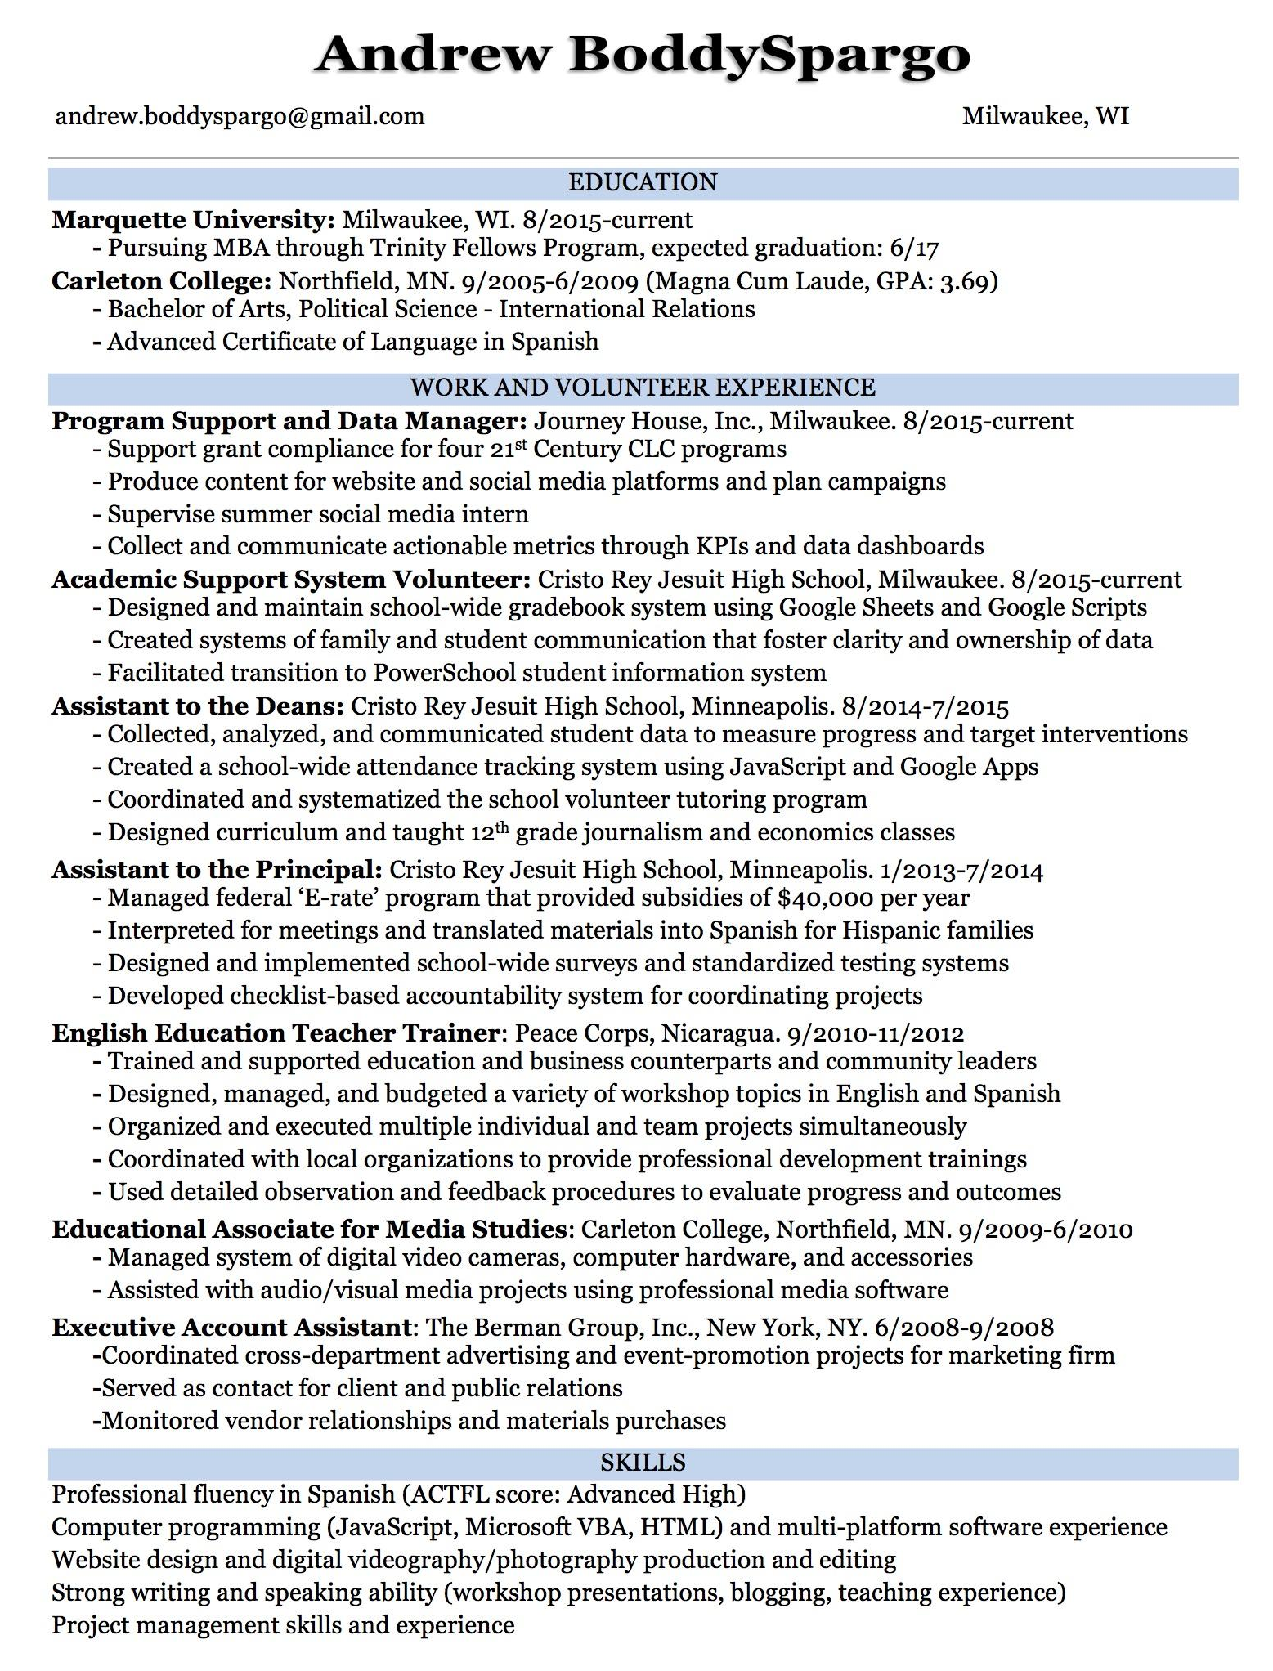

Session 5: How to Keep a Job and Get Promoted
Learning Objectives:  - Measurable student learning (not activities).  - Student-friendly language. | - Students will describe four strategies for keeping and advancing in a job  - Students will define personal brand  - Students will demonstrate two different justifications for promotions or raises
Key Points:  - Central ideas from the lesson.  - What might students have difficulty with? | - To keep a job and get promoted students should be dependable, help others work well, show leadership, have specialized skills  - A personal brand is built on the associations people have with you in the workplace.  - Promotions and raises need to be justified with reasons and evidence
Exit Assessment:  - How will you know if the learning objectives above were achieved? | - Students will define what personal brand means and write an example justification for asking for a raise/promotion.
Heart of the Lesson (Agenda):  - Outline or bullet-point format.  - Lists time-stamped, objectives-aligned learning activities that will guide learning  - Key-point-aligned CFUs (Checks for Understanding) written in bold  - Begins with an Activator and ends with an Exit Assessment (Summarizer) | - Do Now activity:  - Write on the board: “You can either be what happens to you or what you decide for yourself”  - Discuss what it means to decide - set goals, acquire knowledge and skills, make connections  - Ask students to answer the first four questions on the handout [5 min]  - Discuss responses to Do Now - managers usually make more money because they help other people create more value. If you can help lots of people create more value, then you are creating lots more value.  - Introduce topics of brands - “What are some famous brands?” ex: Nike, Apple, McDonalds, H&M, etc. Pick two example brands and ask “What characteristics do you associate with this brand, for example ‘high quality.’” Brainstorm brand associations. Then introduce the concept of a personal brand - what people associate with you at work.  - Present: Build a strong personal brand  - Define: what do you want people to think of when they think of you at work?  - Weak brand: lazy, late, negative, not careful, disrespectful  - Strong brand:  - Dependable - when you’re asked to do something, you always do it  - Hardworking - high quality work, little wasted time  - Positive - enjoy creating value & helping others  - Proactive - what do you choose to do when you don’t have an immediate assignment?  - “How do you create this strong brand? The same way that the companies did; by demonstrating these qualities repeatedly. If you do these things over and over, people will associate you with them.”  - Brainstorm good ways to lose a job  - Remind them of how to make money (create value for others)  - To get promoted or paid more, create more value or become more valuable to your company (or to your clients)  - How can you convince your boss that you are creating more value for them? (connect to all the aspects of a strong personal brand)  - Discuss justifications for promotion/raise  - Increase in responsibility  - If you are doing more work or higher-value work, you deserve more money  - Increase in value  - Gain new skills/knowledge  - Gain experience and get better at your job  - Be creative and offer ideas for improvement  - Discuss how a person can approach their boss for a raise/promotion.  - Do ticket out
Necessary Materials: | - Worksheet with Do Now
Reflection:
- What were the most successful parts of the lesson?
- What will you do differently next time?

Session 5 Worksheet - How to Keep a Job and Get Promoted
Show leadership and enhance your value
Name: __________________________
Do Now:
What does leadership mean to you?

Do you consider yourself a leader, follower, or neither?
Why do you consider yourself this?

Why do you think managers make more money?

Tips for having a strong personal brand:

Good Ways to Lose a Job | Good Ways to Keep a Job & Get Promoted
Justifications for a raise or promotion:

Ticket Out:
Define “personal brand:”

Imagine that you are asking for a raise at a future job. Explain why you deserve a raise:

Session 6: How to Start and Run a Business
Learning Objectives:  - Measurable student learning (not activities).  - Student-friendly language. | - Students will name four different forms of business  - Students will understand and define business functions and terms  - Students will create a basic business plan
Key Points:  - Central ideas from the lesson.  - What might students have difficulty with? | - Different forms of business are better for some things than others  - Business functions require some specialized knowledge
Exit Assessment:  - How will you know if the learning objectives above were achieved? | - Students will create a basic business plan and take the exit assessment
Heart of the Lesson (Agenda):  - Outline or bullet-point format.  - Lists time-stamped, objectives-aligned learning activities that will guide learning  - Key-point-aligned CFUs (Checks for Understanding) written in bold  - Begins with an Activator and ends with an Exit Assessment (Summarizer) | - Do Now activity:  - Before handing out the worksheets, write on the board “Why?” and “Why Not?” and have students brainstorm:  - Why do people start their own business?  - What are some reasons why you might not want to start your own business?  - Pass out worksheets and have them answer the questions by circling Y or N.  - These questions are meant to indicate whether or not a person is suited for starting their own business. The more “Yes” a student circled, the more likely they will enjoy starting a business.  - Present: Forms of Business (info from sba.gov/starting-business/how-start-business/business-types)  - Sole proprietor  - Characteristics: an individual is considered a business  - Benefits: very simple to set up; any profits are just taxed as individual income  - Disadvantages: hard to raise money, individual is liable  - LLC  - Characteristics: treats profit as normal income, but owner(s) are protected  - Benefits: pretty simple, individual is protected from liability  - Disadvantages: limited life, still hard to raise money  - Corporation  - Characteristics: considered a separate organization owned by shareholders  - Benefits: easier to raise money by selling stock, unlimited life  - Disadvantages: more regulations, profit is taxed and owners are taxed on any money they receive from those profits  - Discuss: Which option sounds best to you? Why?  - Present: Functions of a business  - Operations/Supply Chain: make sure materials are purchased, assembly is correct, people know what to do, delivery is on time.  - Marketing: make sure customers know about the product or service and why they should pay for it.  - Information Technology: make sure employees have the working technology they need to do their jobs.  - Human Resources: make sure that the business is hiring, paying, training, and firing its employees intelligently.  - Accounting/Finance: make sure the business is making enough money to cover its costs and has the cash it needs to pay its bills.  - Main idea: business owners should have a basic understanding of each of these functions, but they can hire specialists to be in charge day-to-day  - Review: Business Terms  - Do any students think they know any definitions already?  - Income: money that the business makes from customers and other sources  - Expenses: money that the business needs to pay in order to operate  - Variable Costs: costs that increase with every unit produced (raw materials, supplies, hourly wages, etc)  - Fixed Costs: costs that are the same no matter how many sales (rent, heating, internet bill, administrative pay, etc.)  - Net Income or Net Profit: the money left over after all expenses and taxes are paid  - Business Ownership: owners get to decide how the business operates and get to keep any profits or extra money that it makes.  - Business Plan: a document that explains what a business does, how it will sell its product or service, and how it will pay back investors.  - Activity: Making a business plan  - Further explain what a business plan is: “A business plan is a document that explains what your business does, who it will sell to, how it will communicate and sell, how it will make money, and how much money it expects to make. Usually, the purpose is to convince people to give you the money you need to start or expand the business. Why would people give you money if you don’t have a plan for how you’ll pay them back?”  - Give students one minute to think about what kind of business they might want to start (for this exercise). Tell them that they will write a short business plan for this business. Anyone who cannot think of an example should take an example business idea from the cards in the teacher materials.  - Students get 10 minutes to fill out the one-page business plan and ask questions they might have.  - Do exit quiz  - For completion: one piece of candy  - For 50% or higher, two pieces of candy  - For 80% or higher, three pieces of candy
Necessary Materials: | - Worksheet, materials, quiz
Reflection:
- What were the most successful parts of the lesson?
- What will you do differently next time?

Session 6 Worksheet - How to Start and Run a Business
Find an unfilled need, write a business plan, get investors and staff, get to work
Name: __________________________
Do Now: Circle Yes or No in response to each question:
Are you comfortable with taking risks? Y or N | Do you like to be independent? Y or N
Are you able to persuade others? Y or N | Are you able to negotiate? Y or N
Can you come up with lots of new ideas? Y or N | Do you have a strong support system? Y or N

Forms of Business:
Name | Characteristics | Advantages | Disadvantages
Sole proprietor
Limited Liability Company
Corporation

Business Functions:
- Operations/Supply Chain -
- Marketing -
- Information Technology -
- Human Resources -
- Accounting/Finance -
Key terms:
- Income:
- Expenses:
- Variable Costs:
- Fixed Costs:
- Net Income or Net Profit:
- Business Ownership:
- Business Plan:

More resources: www.sba.gov/starting-business

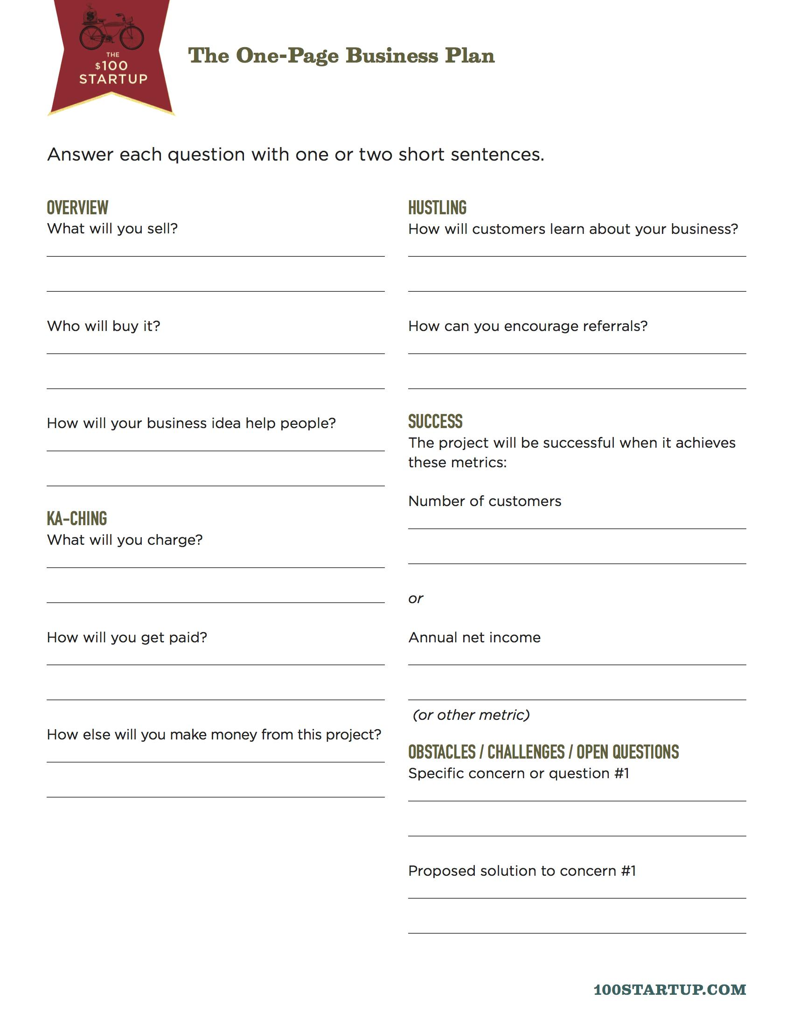

Session 6 Teacher Materials

Business Ideas:
Food Truck Owner | Video Game Store
Lemonade/Soda Stand | Skateboard Manufacturer
Medical Clinic | Video Game Producer
Freelance Writer | Wedding Photographer
Restaurant | Landlord/lady
Ice Cream Producer | Hardware Store
Website Designer | Movie Theater
Movie Producer | Private Jet Rentals
Tour Guide | Computer Repair
Lawncare Company | Farm

Careers and Leadership Pre- and Post-Test
- What do all strategies to make money have in common?  - They all involve getting a job  - You can steal it  - They create value for others  - They create value for the employee  - After taxes, Monique makes $1,900 per month. This is her what?  - Gross income  - Take-home pay  - Annual income  - Bimonthly net pay  - About how much does rent cost each month?  - $100  - $300  - $800  - $4,000  - If a credit card company charges you 20% interest on $100, then $120 is your new:  - Principal  - Interest payment  - Minimum payment  - APR  - Which are ways that credit card companies make money?  - Late fees  - Interest Rates  - Monthly fees  - All of the above  - If your monthly payment doesn’t cover the interest you’re charged, then you will pay off your debt:  - Within one year  - Within five years  - After your interest is paid off  - Never  - The first step to getting a job is to:  - Write a cover letter  - Look for job opportunities  - Go to an interview  - Shake hands and make eye contact  - The main purpose of a resume is to:  - Prove that you’re motivated  - Prove that you’re qualified  - Prove that you’re legal  - Convince an employer to give you a job  - What is a good justification to ask for a raise:  - I have more responsibility now  - I have new skills now  - None of the above  - Both a & b  - What form of business is the same as the individual who owns it:  - Corporation  - Limited Liability Company  - Sole Proprietor  - All of the above  - Costs that go up as production increases are called:  - Fixed costs  - Net profit  - Variable costs  - Business ownership  - What is the function of business that communicates the product or service to customers?  - Operations/Supply Chain  - Human Resources  - Finance/Accounting  - None of the above  - How do you calculate Net Profit?  - Revenues - Expenses  - Expenses + Taxes  - Revenues - Taxes  - Sales - Returns | - ___  - ___  - ___  - ___  - ___  - ___  - ___  - ___  - ___  - ___  - ___  - ___  - ___

Pre- and Post-Test Answer Key
1: C
2: B
3: C
4: A
5: D
6: D
7: B
8: B
9: D
10: C
11: C
12: D
13: A

