March 2017
Let’s “Get Wet” Permission Slip
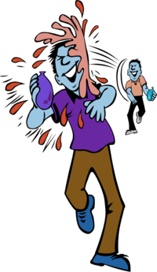

My child ______________________________has permission to participate in the following
type of water activities: Water balloon play, sprinklers, slip and slides, and more.

Location of activity: Albert E. Kagel Elementary School and surrounding field.

- Water Balloon Play - Tossing, catching, and playing various games with water balloons.
- Sprinkler – several sprinkler set up around playground for children to run through
- Slip and slide – set up for children to slide onto and get wet while doing so.
- Water hose – children will be able to use the water hose to play games.

Also, please dress your children in clothes they can get wet and potentially a little messy (with water comes dirt.) Or you can send them with appropriate swimwear.

________________________________ _________________________________
Parent Signature Date

