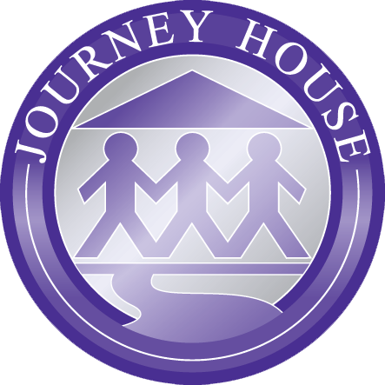
Lesson Plan Template
Journey House, Inc. CLC Program
Leader: |  | Date:

Learning Objectives:  - Measurable student learning (not activities).  - Student-friendly language. | - Students will
Key Points:
- Central ideas from the lesson.
- What might students have difficulty with?

Exit Assessment:
- How will you know if the learning objectives above were achieved?

Heart of the Lesson (Agenda):
- Outline or bullet-point format.
- Lists time-stamped, objectives-aligned learning activities that will guide learning
- Key-point-aligned CFUs (Checks for Understanding) written in bold

- Begins with an Activator and ends with an Exit Assessment (Summarizer)

Necessary Materials:

Reflection:
- What were the most successful parts of the lesson?
- What will you do differently next time?

