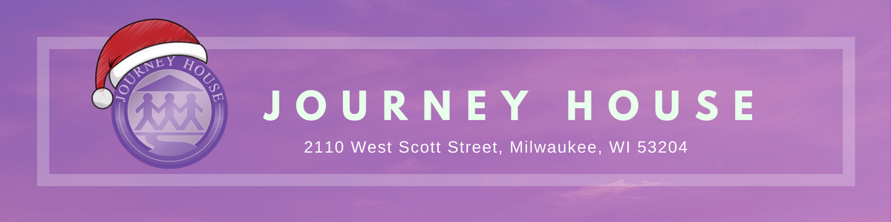

Adopt a Family Sponsor Profile 2018

CONTACT: Cherise Myers at (414) 647-0548 ext. 104

cmyers@journeyhouse.org www.journeyhouse.org

Sponsor’s Name:

Email address:

Phone Number:

Complete address:

Family Size Requested (including adults) OR
Number of individual youth requested (including age range):

Is there a specific type of family/teen you would like to sponsor? Please provide those details:

Would you like to arrange a mutual time to meet your adopted family at Journey House? | Yes No
(For family adoptions ONLY, we do not meet with youth. Meetings must take place at Journey House on or before Friday, December 21st)

Would you prefer to drop off your gifts at Journey House at 2110 W. Scott Street? | Yes No
(Drop off must be completed on or before Friday, December 15th at 6pm)

Would you like the gifts pick up from your location? Please provide the address: | Yes No
(Please schedule your pick-up on or before Friday, December 15th)
Thank you for your generosity and willingness to participate in this meaningful program!

