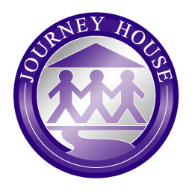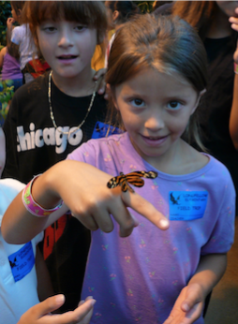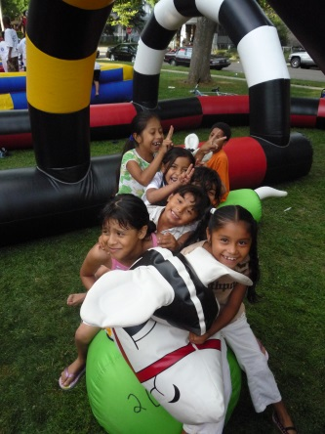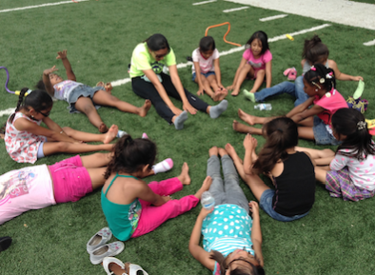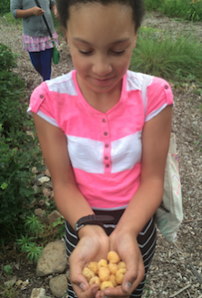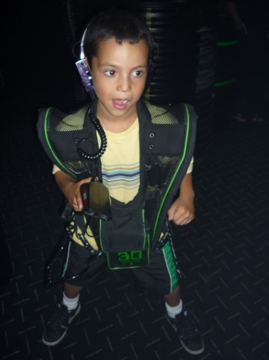

Journey House

2110 W. Scott St  
Milwaukee, WI 53204

journeyhouse.org

Longfellow CLC Coordinator:

(414) 647-0548 ext. 122

Registration begins April 17th and ends

June 12th

## **Journey House**

## Longfellow

## CLC Summer

## Camp

## 2017

Summer Camp is one of the most unforgettable and rewarding experiences in a child’s life. Journey House has been offering these experiences for over 15 years for K5-8th graders. Our Summer Camp allows children to be active, learn to be resilient and make healthy choices, build self-esteem and confidence, keep up with academics, learn new skills, develop friendships, and explore the city, all while having a great summer!

At our Summer Camp,

your child will have the

opportunity to take weekly fieldtrips to places like the beach, the Urban Ecology Center,

and the Milwaukee

County Zoo.

=

Campers will participate in academic enrichment classes, as well as recreational and team-building activities, cooking classes, wellness activities, environmental education, First Robotics, Theatre Camp, science labs, NBA Math Hoops, dance, arts and crafts, and more!

*Additional weeks may be added, extending the end date of the program. Parents/Guardians will be notified of changes at the start of the program.

**The inability to pay does not restrict play.

***Our Summer Camp begins on June 19th and ends on July 28th\****

***Each day begins at 9:00am and ends at 4:00pm.***

**The program fee is $50 per child\*\***

**This includes breakfast, lunch, dinner, a camp T-shirt, and registration fees.**

# CLC Summer Camp 2017